**Detailed dataset information sheet**

|  |  |
| --- | --- |
| **Information Objective** | Roads and Transport Hubs |
| **Data Products** | Woolworths Distribution Centres |
| **Information Source / Model Product** | [Woolworths Distribution List](https://www.wowlink.com.au/wps/portal/topic_centre?WCM_GLOBAL_CONTEXT=/cmgt/wcm/connect/Content%20Library%20-%20WOWLink/WOWLink/Topic%20Centre/B2B/GLN/WOWDCDirectory), Google Maps, Earth and Search Engine |
| **Product Completion Progress** | Woolworths Distribution Centres complete |
| **Dataset / Metadata Document** | Australia_Woolworths_Distribution_Centres_Unique_GPS.shp  Woolworths Distribution Centre Locations Metatadata.pdf |
| **Dataset Use** | Surveillance Strategy and Design, Pathway risk analysis |

**Background**

A national point feature spatial dataset layer identifying major distribution centres for Woolworths has been developed utilising publicly available information from Google Earth, Google Maps and associated search engine.

The initial facilities for these corporate entities were identified from Woolworth’s corporate website and an excel spreadsheet published online that contained all their general and product specific distribution centre locations nationally.

**Initial Dataset Procurement Process**

The dataset has been derived by a number of manual processes:

* The list of Woolworths distribution centres for Australia was sourced from their corporate website and manually geo-coded.
* GPS coordinate values were extracted by visually inspecting and then mapping these sites using Google Maps and Google Earth (Figure 1)
* The excel spreadsheet was imported into ESRI’s ArcMap and converted into a feature layer
* In the course of locating and visually confirming each site, some of the current ownership details were found to be incorrect or incomplete
* Incorrect and incomplete information was fixed were possible using information from Google’s search engine as per the metadata statement for each dataset
* Other distribution centres had multiple entries of the same address, possibly due to co-location of individual business operations within the same building
* Sites were filtered for unique locations and only the remaining sites were geo-coded (details of this can be found in the Australia-Woolworths-National-Distribution-Centres-May-2018.xls spreadsheet (Figure 2)

Figure 1. Google Earth view of a Woolworths Distribution Centre

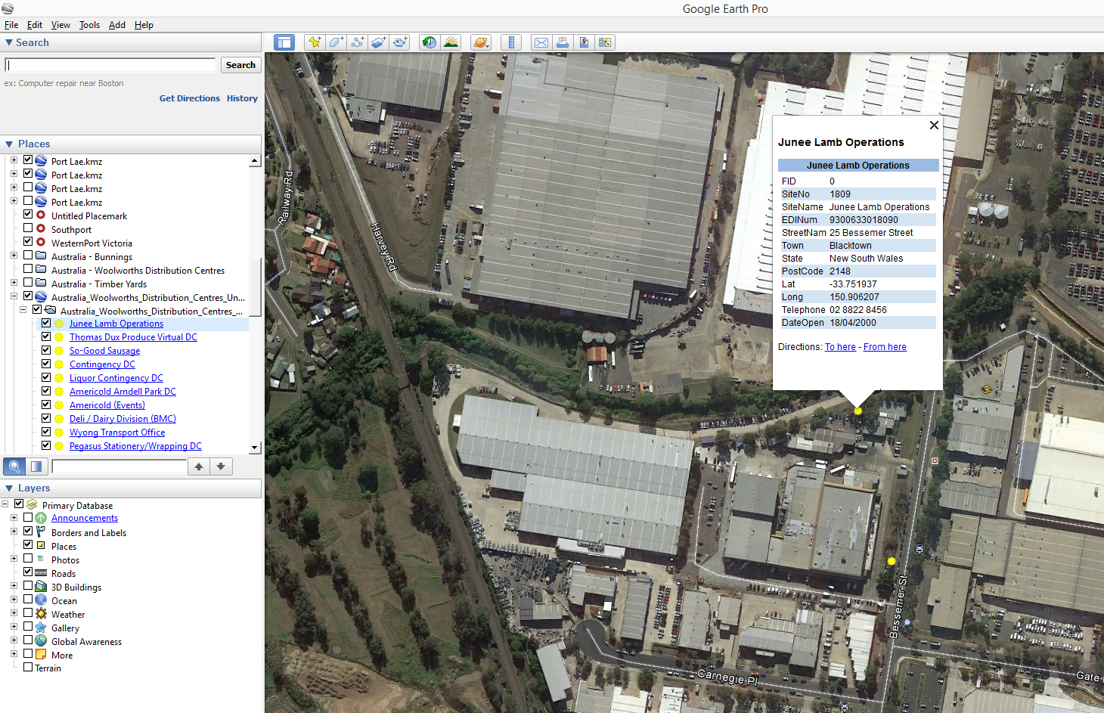

Figure 2. Excel spreadsheet view of a Woolworths Distribution Centres after geo-coding

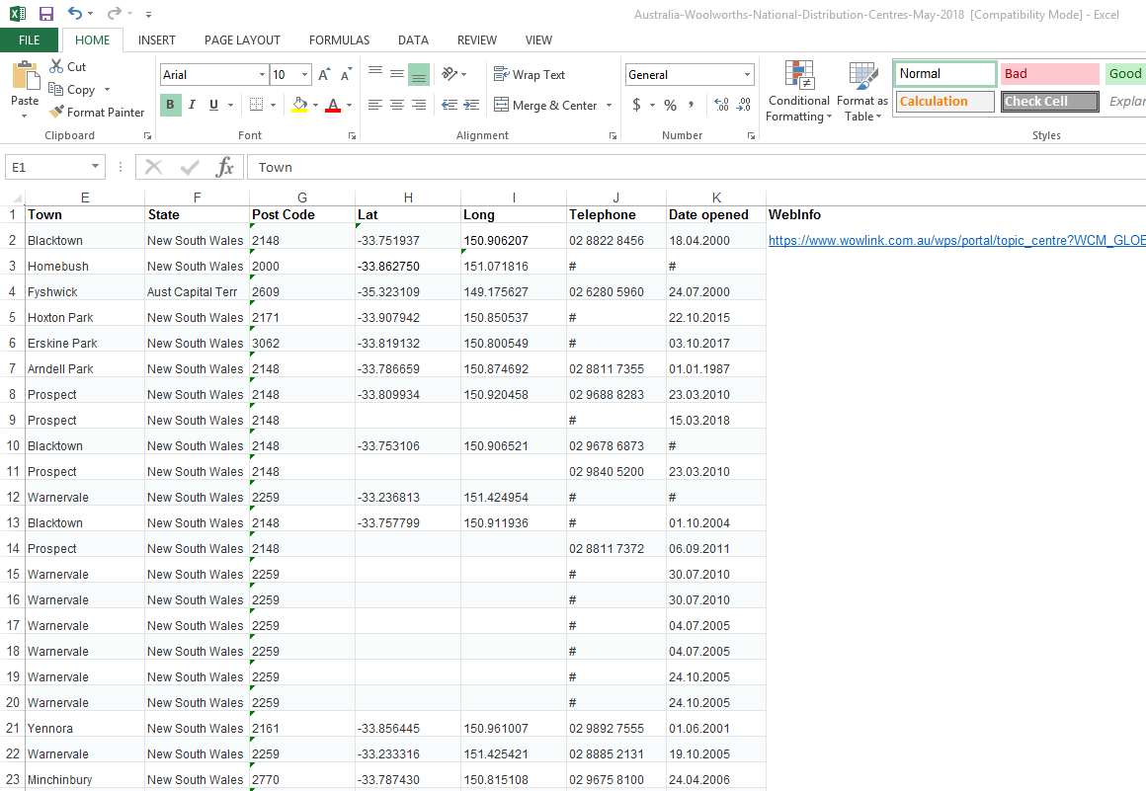

**In progress Dataset Procurement Processes**

No further data procurement is required. From information available online this dataset is complete.

As new sites are opened or existing sites closed, this dataset will need to be reviewed and updated periodically.

**Limitations**

* None considered at this stage of the procurement

**Quality Check**

* The corporations could be contacted to confirm operational status of these sites and for advice on new locations under construction or to be constructed

Table 1. Summary of the datasets and their completion status to date

|  |  |  |  |  |
| --- | --- | --- | --- | --- |
|  | **Initial feature Count** | **Additional features detected using online sources** | **Estimated number of distribution centre features to be captured** | **Estimated total feature count of completed dataset** |
| **Woolworths Australia** | **47** | **0** | **0** | **47** |

Discussion and Future Work

Future work may include quality assurance checks to confirm ownership details and ensure facilities identified are still operating.

Calculation of useful feature attributes such as:

* Proximity in kilometres to major freight hubs, AA ports of entry and community gardens

Project Resources Estimates and Uses

An estimate of the timeframes and data procurement requirements required to complete this dataset is summarised in Table 2.

The end result will be a dataset product which is of a High to Authoritative quality and can be referenced as a point of truth data source for input into projects such as surveillance strategy and design.

This dataset will provide accurate and useful information such as:

* Woolworths major distribution centres
* Ownership and Contact information
* Area sizes

And will assist in:

* Serving as an input in estimating labour and capital resources for conducting surveys for pests such as those in the National Priority Plant Pests (NPPP) target groups
* Mapping requirements for national/state emergency response programs that are deployed when these pest incursions occur
* Providing a feed-in data layer alongside the national road network for determining distribution pathways and the risk levels of these pathways

Table 2. Comparison of process methods and output dataset quality expectations

|  |  |  |  |  |
| --- | --- | --- | --- | --- |
| **Process** | **Requires Industry Assistance** | **Requires State Government Assistance** | **Estimated time to complete** | **Expected Dataset Quality Level** |
| Woolworths | Possibly – for quality checking operational status and ownership details of identified facilities | No | Complete | High to Authoritative |